Maine Winter Brain Conference 2015

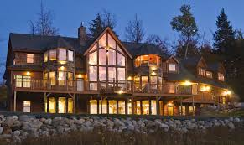
Location: GlennHaus, Sunday River, Bethel, Maine
For directions etc go to http://www.sundayriverrentals.com/

Dates: 01/20/2015 – 01/22/2015

Schedule:

Tuesday afternoon:
5pm Welcome
5:30 – 6:30: Josua, Maxim, Yu Hu

6:30 – 8:00: dinner

8:00 – 10:00: talks Dimitar, James, David, Rob Johnson, Eva, Tim

Wednesday morning:
8:00 – 10:30: talks Iris, Martin, Clemens, Owen

Wednesday evening:
5:30 – 6:30: talks Xiuye, Caroline, Thomas

6:30 – 8:00: dinner

8:00 – 10:00: talks: Harvey Lab

Thursday morning: Departure

